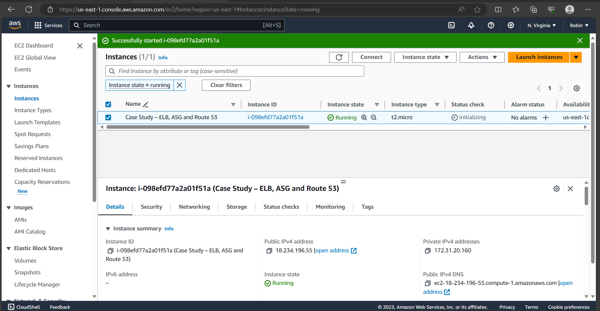

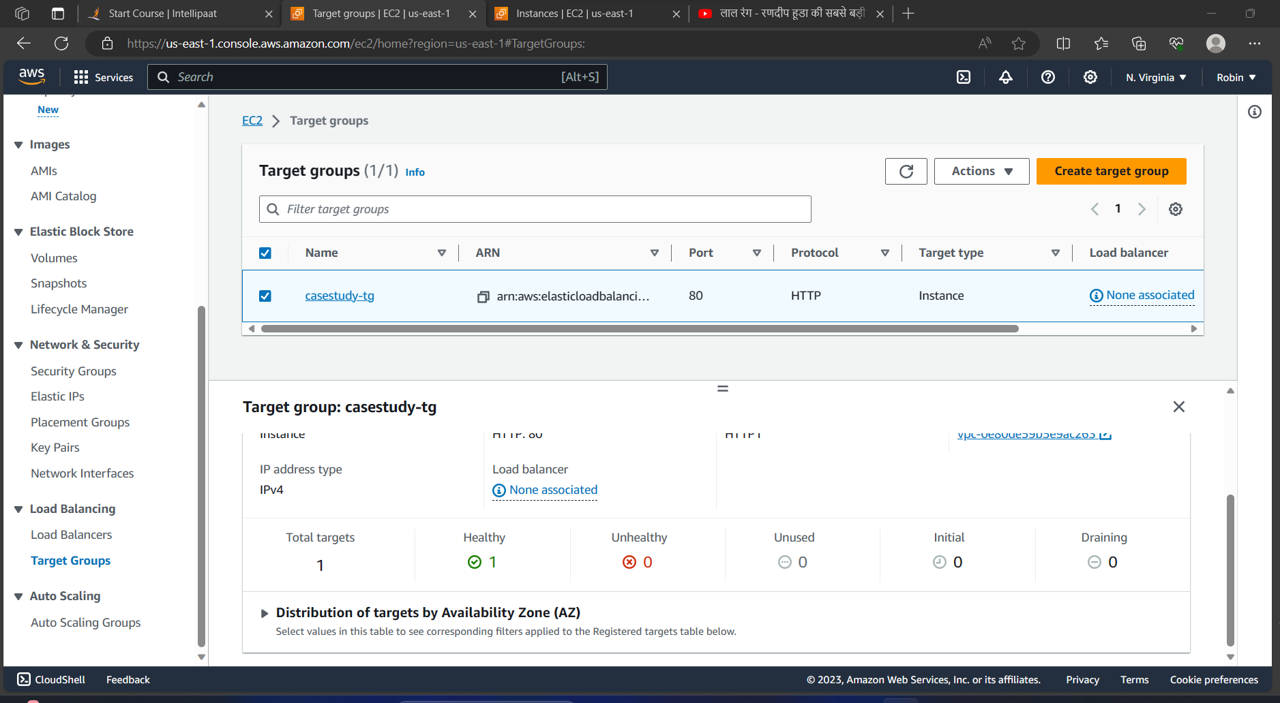

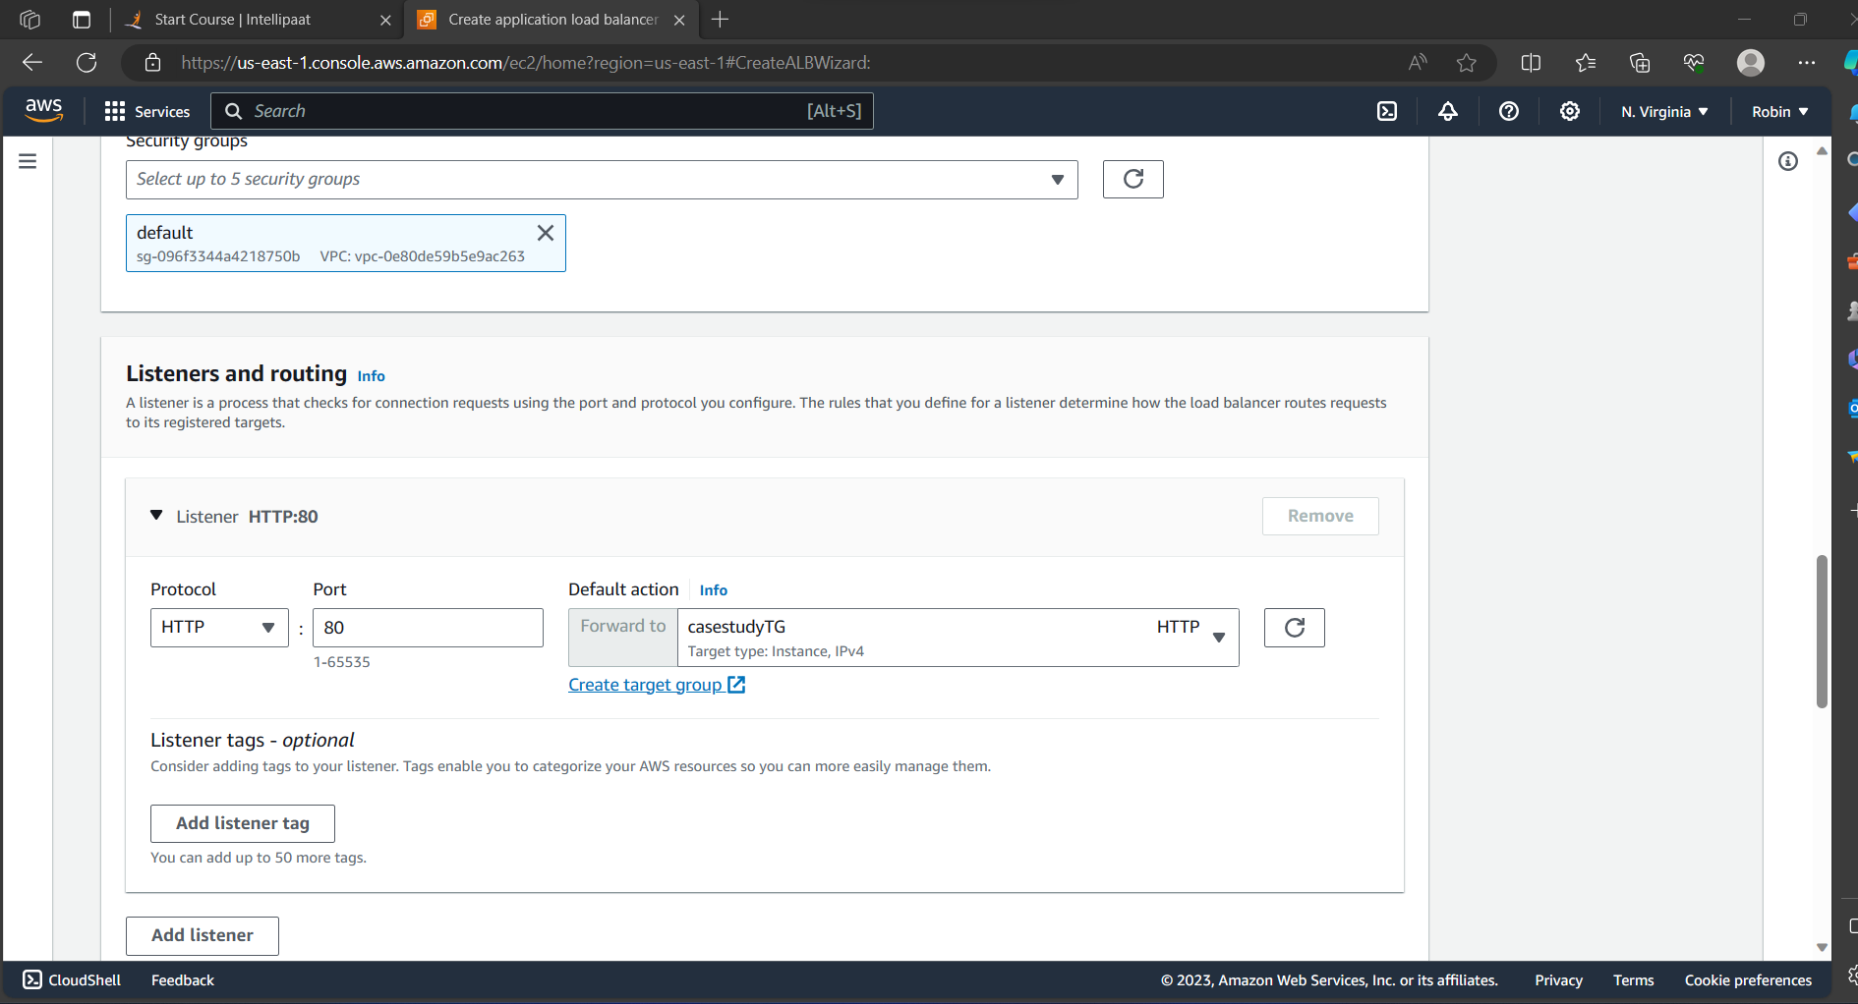

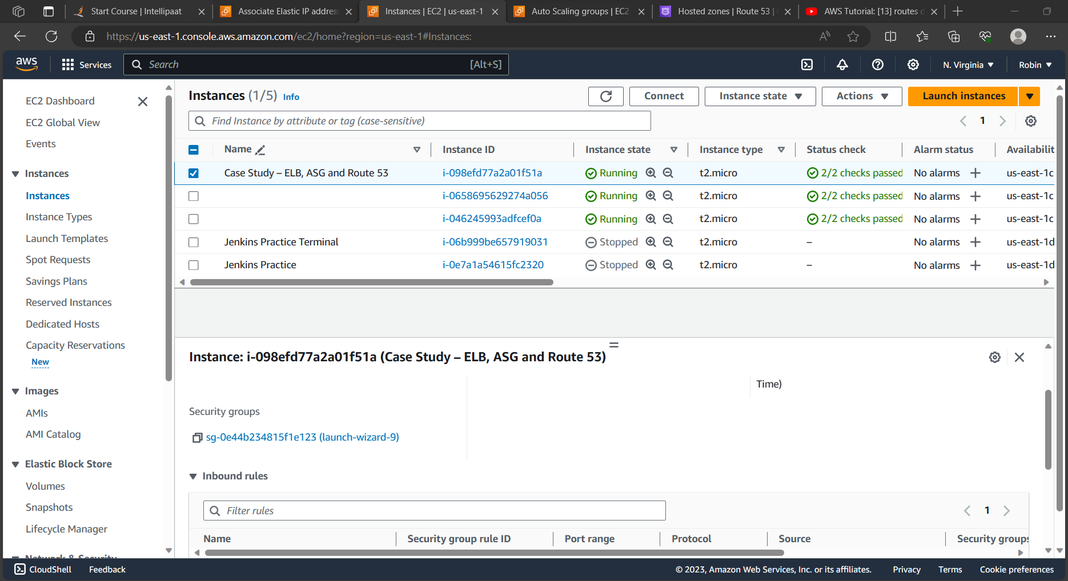

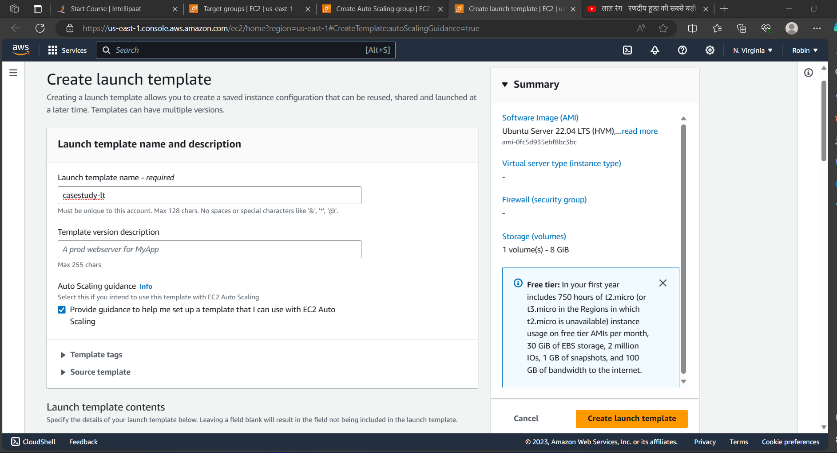

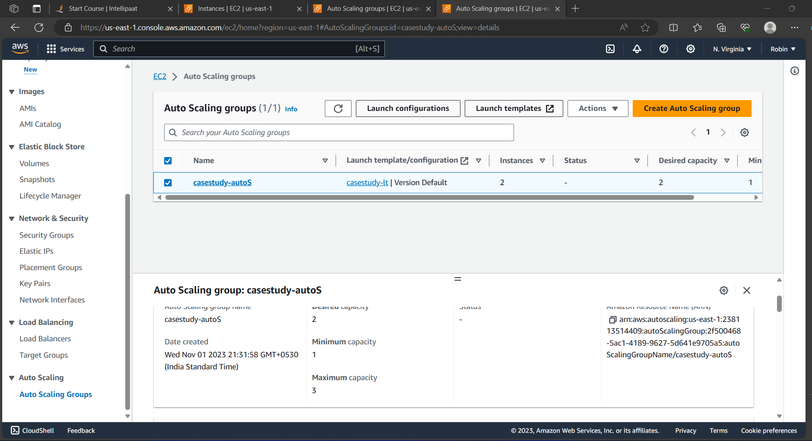

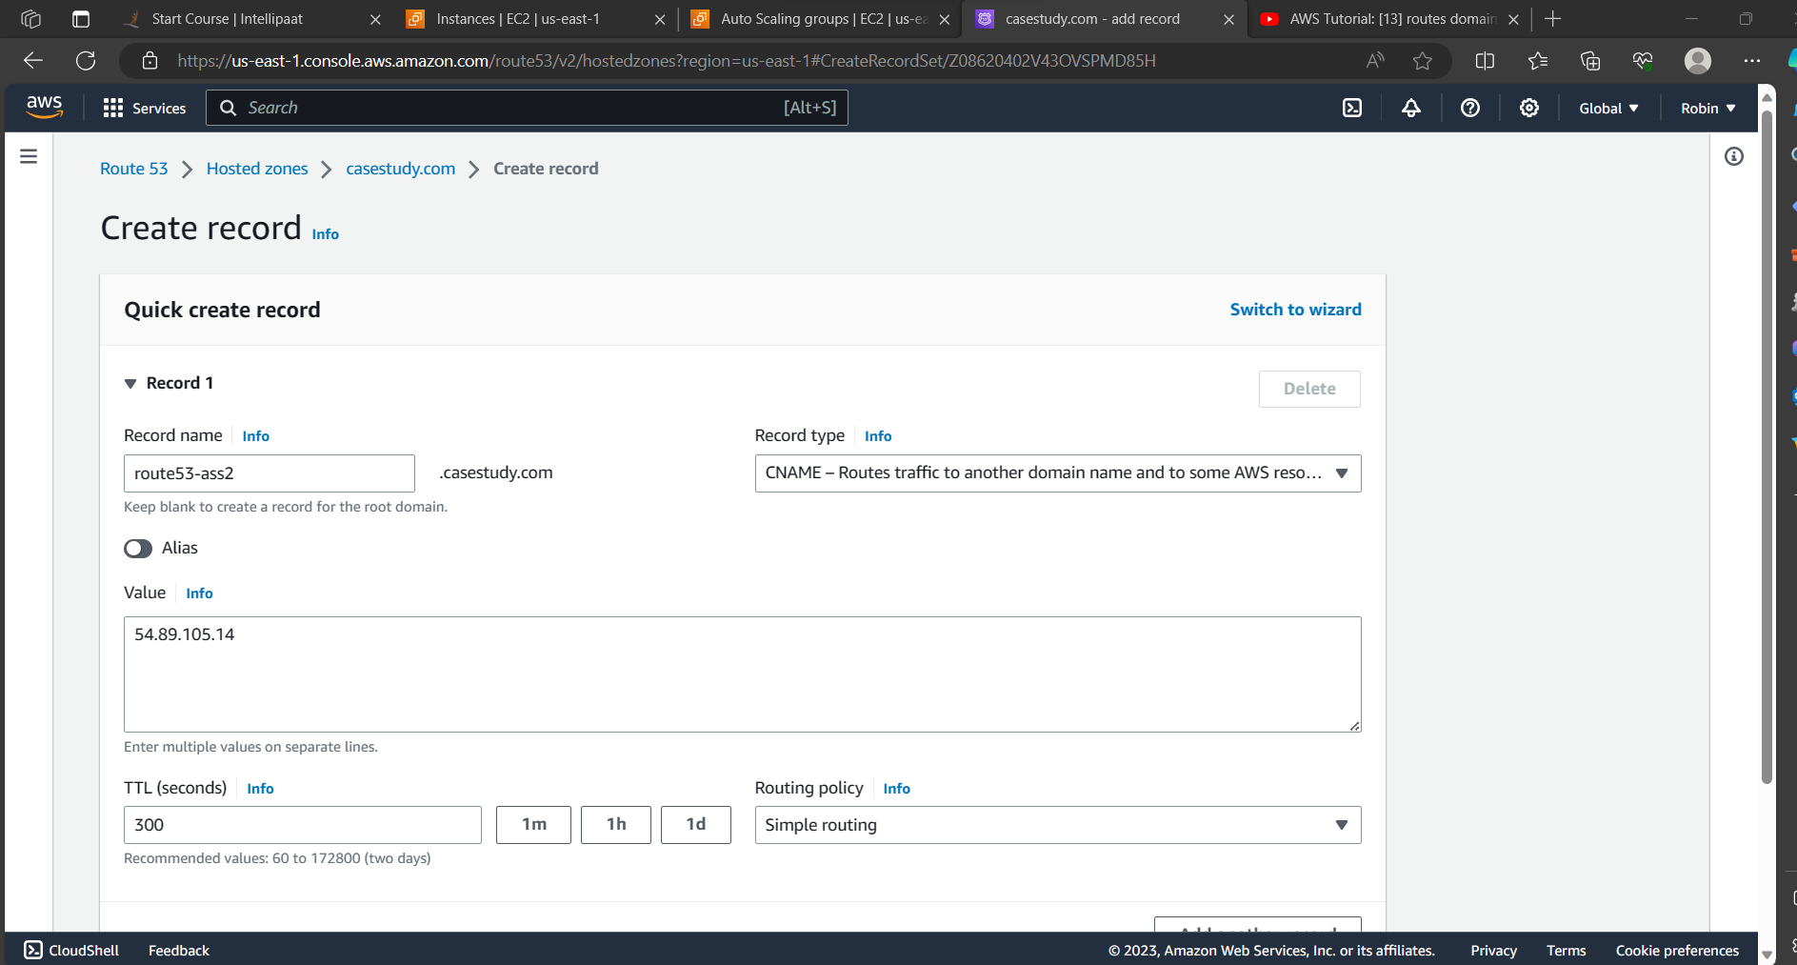

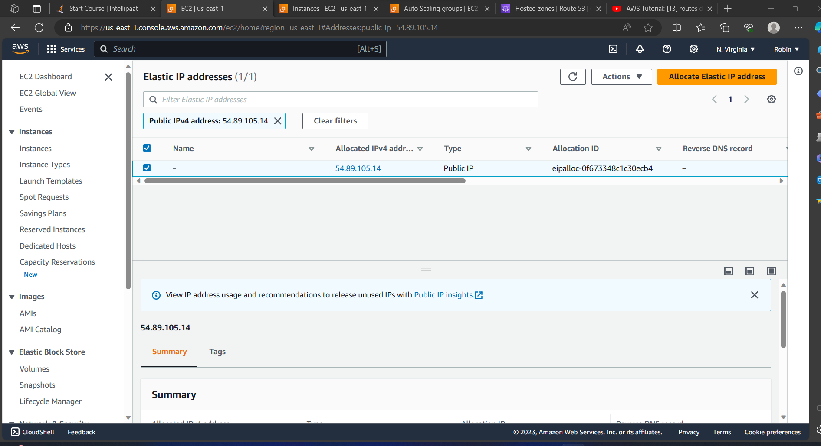

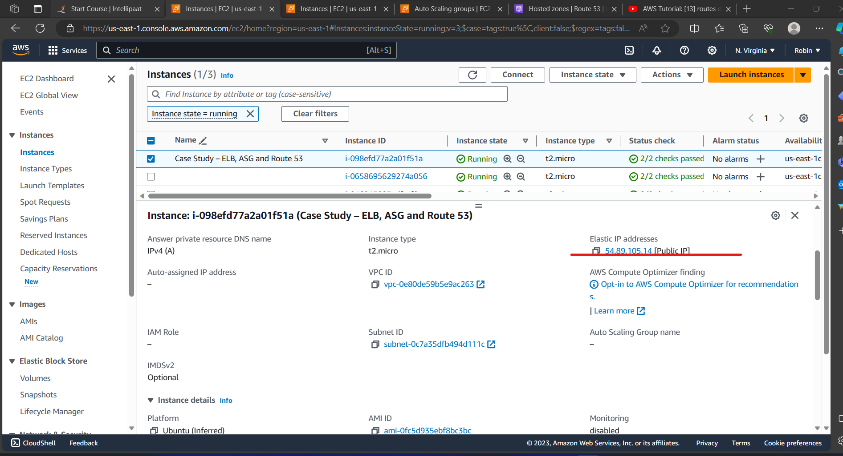

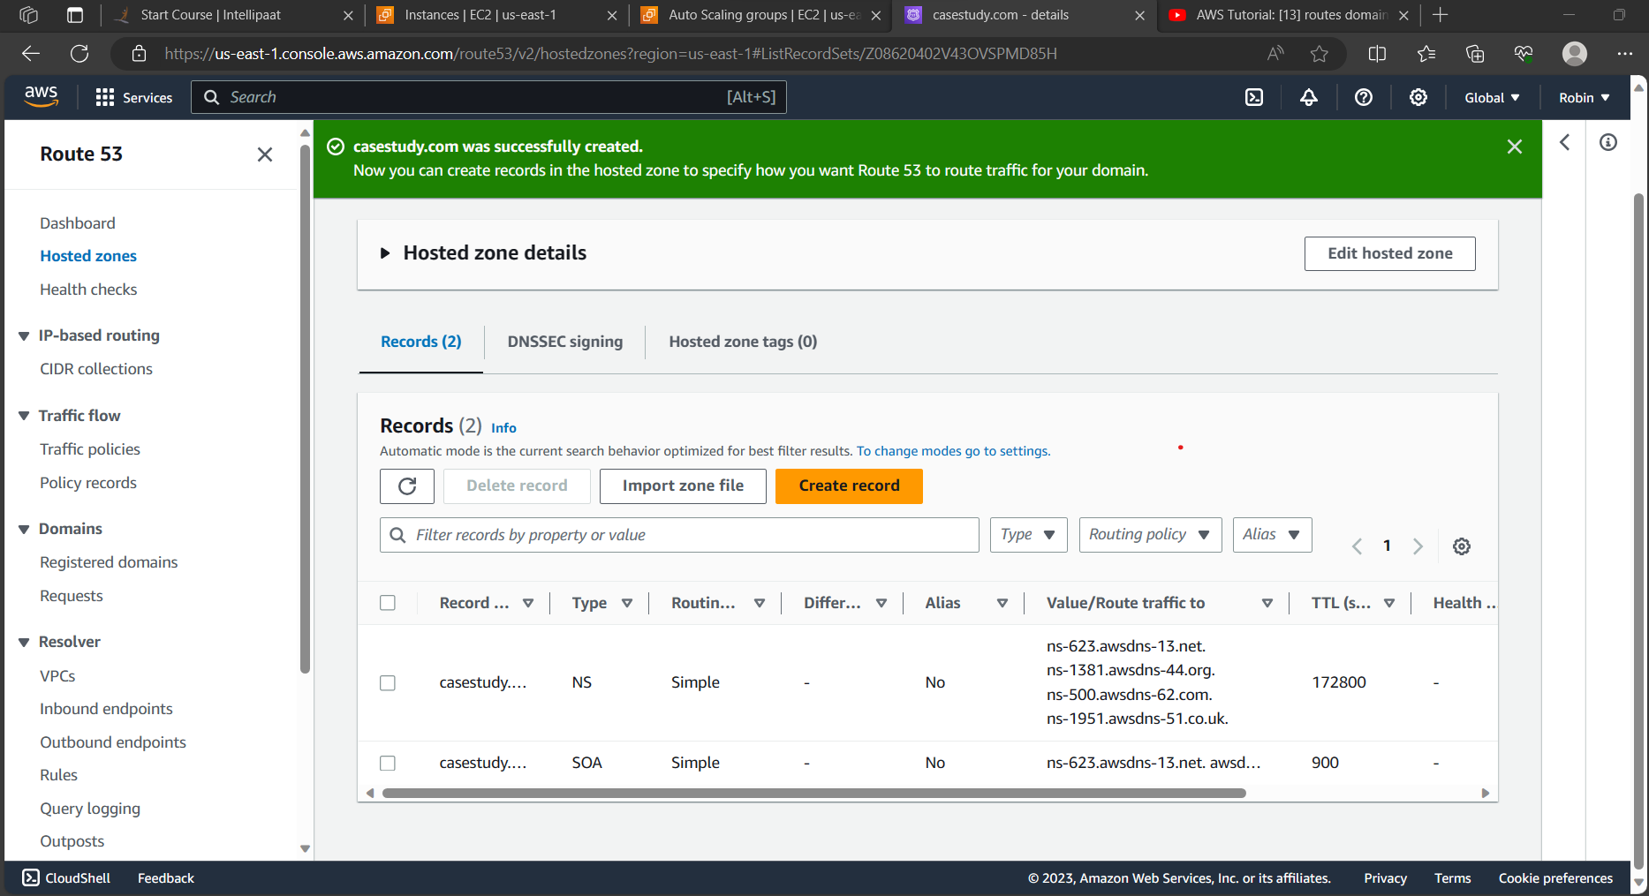

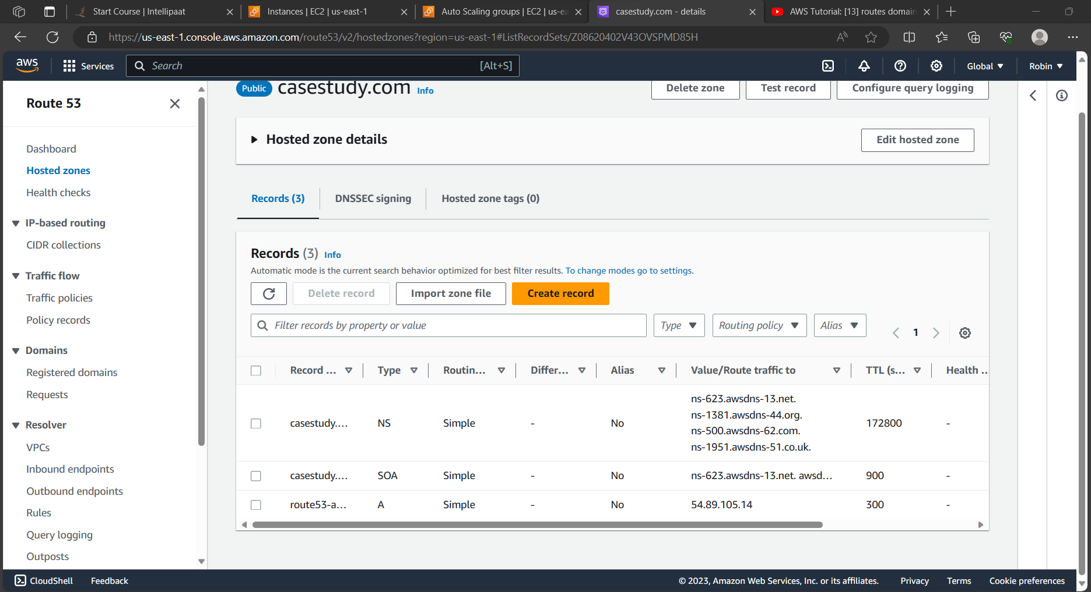



The further steps are typed below as in domain registration charges are applicable

1. After creating the records, click on casestudy.com in records which have TTL as 172800 which will have 4 values in it i.e. ns-623.awsdns-13.net, ns-1381.awsdns-44.org, ns-500.awsdns-62.com and ns-1951.awsdns-51.co.uk.
2. You will have to paste all of these values in nameservers in domain registration server on jagoweb and click on create nameservers.
3. So basically here we are replacing the values which are present in the hosted zones.
4. Open the browser i.e www.casestudy.com